

Dear McMullen-Booth Elementary Families,

At school your child is currently receiving individualized reading instruction through the use of the computer-delivered program Istation. Your child can now continue his or her reading experience through unlimited access to Istation Reading at home! Istation is an internet-based comprehensive reading intervention program that ensures that students reach their full reading potential. It is and adaptive research-based formative instruction application based on the Florida State Standards for reading.

The next step is to install Istation on your home computer. This is a quick and easy process. Go to <http://www.istation.com/Support/DownloadIstation> and follow the simple installation instructions.

**School/Domain:** mcmullenbooth.pinellas.fl

Once you have downloaded the program to your computer, click on the application icon to log in. It looks like the picture below.



User Name: R2D2 (students username WITHOUT the period).   
Password: s.######## (s.password)

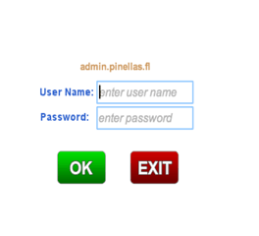

**If you have any questions on accessing Istation please contact your child’s teacher.**